Linux Commands
Syntax : command name + options + arguments

1. man command:
Purpose : this command is used to display the user manual of any command we can run on the terminal.
Syntax : man command name
Example : man pwd
Output:
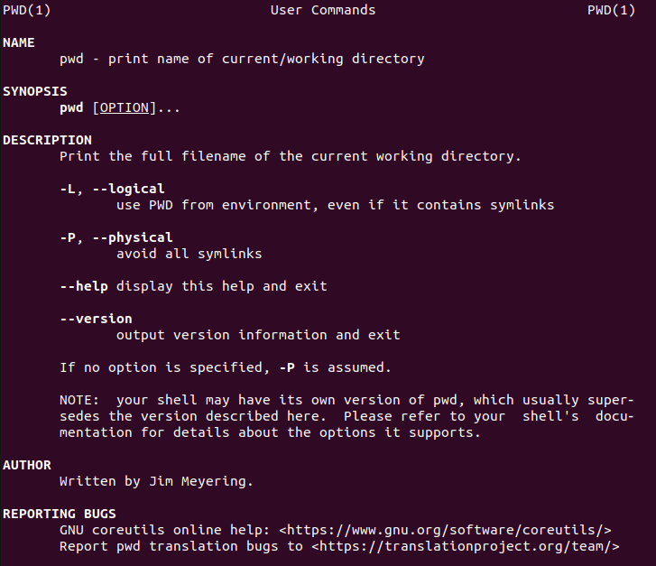

2. pwd command :
Purpose : This command is used to print the name of the working directory.
Syntax : pwd [options]...
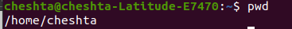
Example : pwd
Output:

Options:
~ -L : (Logical): Displays the path based on environment variables, including symbolic links.
~ -P : (Physical): Displays the actual, physical path, resolving all symbolic links to their real location.
~ --help : Displays help information about the command and its usage.
Example: pwd --help
Output:
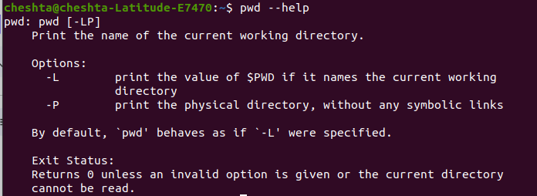

3. ls command :
Purpose : This command is used to list all the content of the directory.
Syntax : ls [option]... [file]...
Example : ls
Output :

Options:
~ -l : Displays a long listing format, including file permissions, number of links, owner, group, size, and last modification date and time.
Output:
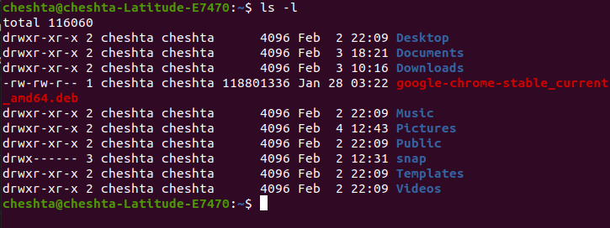

~ -a: List all files, including hidden files that start with a dot (.).
Output:
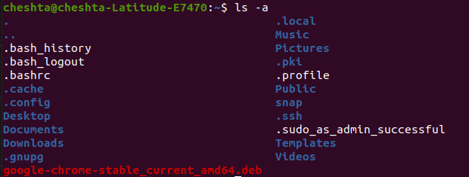
~ -h: With -l option (ls -lh), prints file sizes in human-readable formats instead of bytes.
Output:
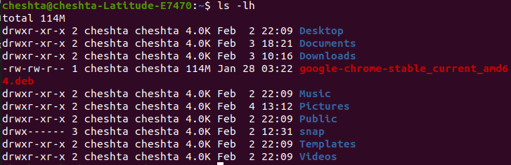
~ -t: Sorts by modification time, newest first.
Output:
~ -d: Lists information about directories themselves; rather than their contents.
Output: Here “.” means current directory.
~ -F: Appends an indicator(e.g., / for directories, * for executable files) to entry names to show file type.
Output:
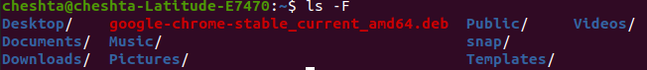

~ -r: Reverses the sorting order. When combined with -t (ls -ltr), it lists the oldest file first.
Output:
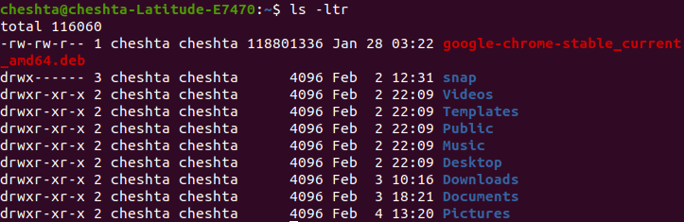
~ -i: Prints the inode number(index number) of each file or directory.
Output: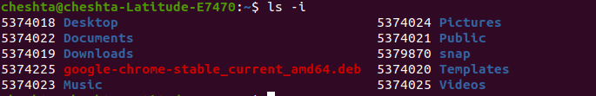
~ -s: Sorts by file size, largest first.
Output:
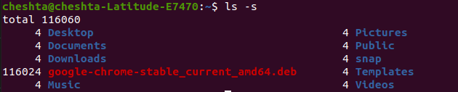

4. cd command:
Purpose: Used to change the current working directory.
Syntax: cd [options]
Example: cd
Output:
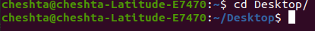

Options:
~ cd ~ : Changes the directory to the user’s home directory.
~ cd - : Toggles back to the previous working directory, which is useful for switching between two locations.
~ cd .. : Moves one level up the directory tree.
~ cd / : Changes the directory to the file system root directory.
~ cd [path] : Changes to the directory specified by the path, which can either be absolute path or relative path.
~ cd -L [path] : Follows the logical directory structure.
~ cd -P [path] : Changes the directory to the physical(real) path, resolving any symbolic link.

5. mkdir command:
Purpose: This command is used to make directories.
Syntax: mkdir [option].... Directory…
Example: mkdir movies
Output: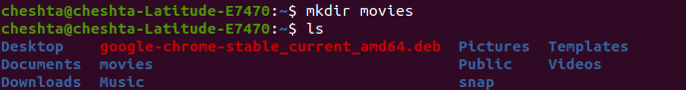

Options:
~ -p: Creates parent directories as needed. For example, If want to create a directory app inside project but project directory does not exist than we can use -p as
mkdir -p project/app .
~ -m: This allows you to set the file permissions(mode) for the new directory.
~ -v: This option prints a message for each directory that is successfully created, providing confirmation of the operation.
~ --help: Displays a help message with all the available options and exits.
~ --version: Outputs version information about the mkdir command and exits.

6. touch command:
Purpose: Used to create an empty file or update the access and modification time of existing files.
Syntax: touch [Option].... File…..
Example: touch abc
Output: 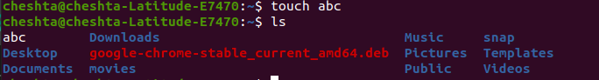

Options:
~ -a: Change only the access time.
~ -m: Change only the modification time.
~ -c: Do not create any files that do not exist.
~ -d: Use the specified time/date string instead of the current time.
~ -r: Use the timestamp of a specified reference file instead of current time.
~ -t: Use a specific time specified in the format.

7. nano command:
Purpose: Text editor that operates within a terminal window.
Syntax: nano [Options]...
Example: nano abc.txt
Output: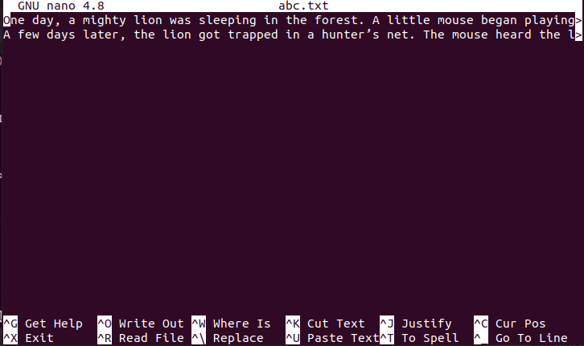

Options:
~ -l: Show line number.
~ -c: Show cursor position, row and column number at bottom.
~ -m: Enable mouse and allow it to click select and scroll.
~ -i: Keeps indentation while writing code.
~ -w: Disable word wrapping, long lines stay in one line.
~ -B: Creates backup files.
~ -E: Converts tabs to spaces.
~ -R: Read only mode, prevents accidental editing.

8. rmdir command:
Purpose: Deletes a directory only if it's empty.
Syntax: rmdir [Options].... Directory….
Example: rmdir movies
Output:
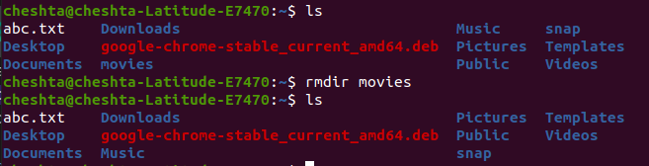

Options:
~ -p: Removes the specified directory and its ancestor directories in the path, provided they are also empty after the child directory is removed.
~ -v: Displays a diagnostic message for every directory processed or removed.
~ --ignore-fail-on-non-empty: Suppresses the error message that is typically shown when trying to remove a non-empty directory. NOTE- It only ignores the error message, does not remove the directory.
~ --help: Displays help information and exit.
~ --version: Outputs version information and exit.

9. rm command:
Purpose: Permanently removes files and directories. Files deleted using this command cannot be recovered from the recycle bin.
Syntax: rm [Option]... [File]...
Example: rm aaa.txt
Output:
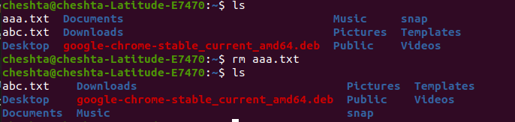

Options:
~ -r: This option is used to remove directories and all of their contents recursively.
~ -f: This ignores nonexistent files and arguments, and overrides any confirmation prompts. Allows deletion without asking for confirmation, even if files are write-protected.
~ -i: Prompts for confirmation before every removal.
~ -I: Prompts only once before removing more than three files, or when removing recursively.
~ -v: Explains what is being done by printing the name of each file as it is removed.
~ -d: Removes empty directory. This provides the same functionality as the rmdir command.

10. cp commands:
Purpose: This command is used to copy files and directories.
Syntax: cp [Option]... source/Directory… Directory/source
Example: 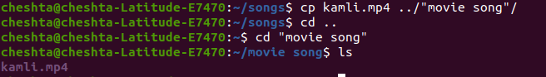

Options:
~ -a: Preserves specified attributes(mode,ownership, timestamps, links, etc.).
~ -f: Forces the removal of an existing destination file if it cannot be opened for writing before attempting to copy.
~ -i: Prompts for confirmation before overwriting an existing file.
~ -n: Prevents overwriting existing files.
~ -p: Preserves the original file attributes, including modification time, access time, ownership, and permissions, in the copy.
~ -r or -R: Recursively copies directory, including all their files and subdirectories
~ -u: Copies only when the source file is newer than the destination file or when the destination file is missing.
~ -v: Explains what is being done by showing the files as they are copied.

11. mv command
Purpose: The mv command is used to move or rename files and directories.
Syntax: mv [Option]... Source… destination…
Example: mv bhajan.mp4 ../”movie song”
Output:
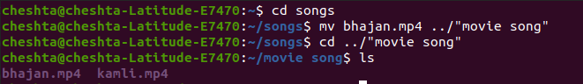

Options:
~ -i: Prompts for confirmation before overwriting an existing file. An affirmative answer(usually y is required to proceed with the overwrite; any other response cancels the move for that specific file.
~ -f: Forces the move to happen without prompting for confirmation, even if the destination file is write-protected.
~ -n: Prevents overwriting an existing file. The file will simply not be moved if a file with the same name already exists in the destination.
~ -v: Displays a message for each file that is moved showing the source and destination path.

12. cat command:
Purpose: The cat command is used to display content of a file.
Syntax: cat [Option]... [File]...
Example: cat abc.txt
Output:
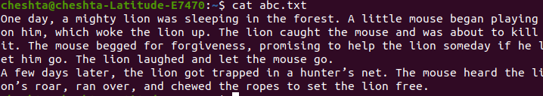

Options:
~ -n: Number all output lines including black ones.
~ -b: Number nonempty output lines.
~ -s: Suppress repeated empty output lines, replacing multiple consecutive blank lines with a single black line.
~ --help: Display help information and exit.
~ --version: Output version information and exit.
~ > : To create a new file and enter data in it.

13. less command:
Purpose: A powerful file viewer offering numerous options and in-program commands for navigating and viewing large files efficiently.
Syntax: less file_name
Example: less abc.txt
Output:
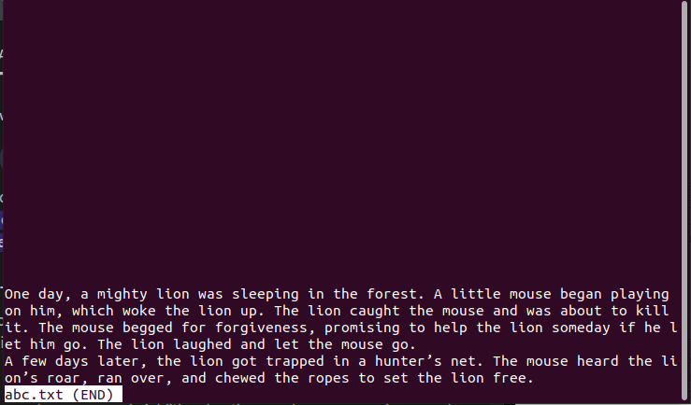

Options:
~ -N: Displays line number.
~ -F: Exit if the file fits on one screen.
~ -E: Exit upon reaching the end of the file for the first time.
~ -i: Ignore case in searches unless uppercase letters are used.
~ -I: Always ignore case in searches.
~ -s: Condense multiple blank lines into one.
~ -? or --help: Show a summary of commands and options.

14. grep command:
Purpose: Used to search for specific words, phrases, or patterns inside text files.
Syntax: grep [Option…] Patterns…. [File…]
Example: grep “lion” abc.txt
Output:

Options:
~ -i: Enable to search case insensitively in the given file.
~ -c: To find the number of lines that match the given pattern.
~ -l: Display the files that contain the given pattern.
~ -w: Matches only the whole word.
~ -o: To display only the matched pattern rather than the whole line.
~ -n: To show the line number of files with the line matched.

15. whoami/who command:
Purpose: To display information about the user who is currently logged onto the system.
Syntax: whoami [Option]...
Example:

Options:
~ -h or --help: Display a help message and exit.
~ -V or --version: Displays version information and exits.

16. tac command:
Purpose: It concatenates and prints files in reverse.
Syntax: tac [Option]... [File]...
Example: tac aa.txt
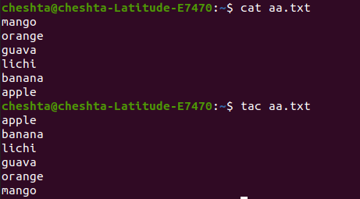

Options:
~ -b: Attach the separator before each line of output instead of after.
~ -r: Interprets the separator as a regular expression.
~ --help: Displays the help information and exits.
~ --version: Outputs version information and exits.

17. rev command:
Purpose: It reverses the lines characterwise.
Syntax: rev [Option] [File…]
Example: rev aa.txt
Output:
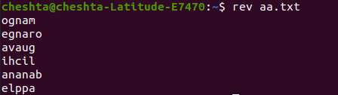

Options:
~ --help: Displays a help message and exits.
~ --version: Prints the version information and exits.

18. head command:
Purpose: This command is used to output the starting part of a file.
Syntax: head [Option]... [File]...
Example: head -2 aa.txt
Output:
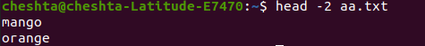

Options:
~ -n num: Print the first num lines.
~ -c num: Print the first num bytes.

19. tail command:
Purpose: This command is used to output the end point of a file.
Syntax: tail [Option]... [File]...
Example: tail -3 aa.txt
Output:
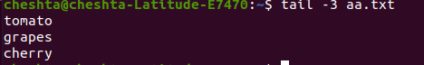

Options:
~ -n num: Displays the last num of lines.
~ -c num: Displays the last num bytes of file.
~ -f: Continuously monitors the file for changes and displays new lines as they are added. Terminate with ctrl + c.

20. sort command:
Purpose: Use to sort the file.
Syntax: sort [Option]... [File]
Example: sort aa.txt
Output:
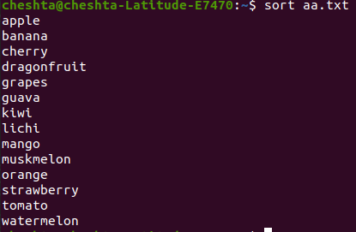

Options:
~ -n: Sorts according to numerical value.
~ -r: Sorts in reverse order.
~ -u: Outputs only the first of an equal run, effectively removing duplicates and providing a unique sorted list.
~ -f: Folds lowercase character to uppercase for comparison, allowing for case-insensitive sorting.
~ -c: Checks whether the input file is already sorted according to the specified option and reports if it is not.

21. echo command:
Purpose: Used for displaying text on the screen.
Syntax: echo [Short-Option]... [String]...
Example: echo Hello, how are you?
Output:

22. find command:
Purpose: Used to search for files and directories based on various criteria.
Syntax: find [path] [Option] [expression]
Example: find aa.txt
Output:

Options:
~ -name “filename”: Searches for files with a specific, case-sensitive name.
~ iname “filename”: Perform a case-insensitive name search.
~ -type [f|d|l]: Filters results by filetype: f for regular files, d for directories, l for symbolic links.
~ -empty: Locates empty files or directory.
~ -prune: Excludes a specific directory from the search.
~ -delete: Deletes all found files or empty directories.

23. chmod command:
Purpose: Used to modify the read, write, and execute permissions of files and directories.
Syntax: chmod [Option]... Mode[Mode] [file]
Example: chmod u+x aa.txt
Output:
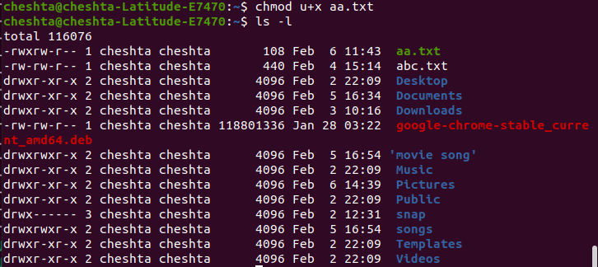

Options:
~ -c: Like verbose(-v), but reports only when a change is actually made.
~ -f: Suppresses most error messages.
~ -v: Outputs a diagnostic message for every file processed.
~ -R: Changes files and directories recursively within a specified directory tree.

24. sudo command:
Purpose: Allows a permitted user to execute commands with elevated privileges, typically as the root user.
Syntax: sudo [options] command [arguments]
Example: sudo -l
Output:
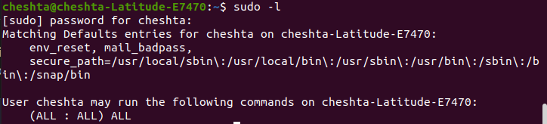

Options:
~ --help: Displays help message.
~ --version: Print sudo version.
~ -v: Updates cached credentials.
~ -k: Invalidates cached credentials.
~ -K: Removes cached credentials entirely.
~ -l: Lists allowed/forbidden commands.
~ -n: Prevents password prompt.

25. apt command:
Purpose: A high-level command-line interface for the advanced packaging tool system.
Syntax: sudo apt [options] <command> [package(s)]
Example: sudo apt update
Output:
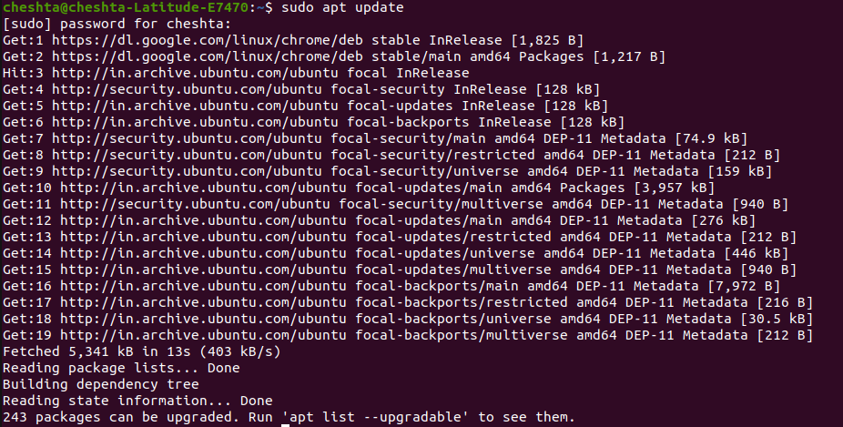

Options:
~ -y: Assumes yes automatically as the answer to all prompts, running non-interactively.
~ -d: Downloads package files but does not unpack or install them.
~ -f: Attempts to correct a system with broken dependencies.

26. snap command:
Purpose: Snap is a modern package management system developed by Canonical.It installs applications as snap packages (self-contained, with dependencies included).
Syntax: snap options
Example: snap list
Output:
